'''

A group of people planned to go an Island for New Year celebrations,

They have arrived at a boating point to reach the Island. All of them

formed in a line to get into the boat, and you are given their weights

as an array Weights[], where i-th person weight is Weights[i].

Each boat can carry only few people whose total weight is atmost W.

Each person get into the boat according to the given order only.

The boat takes T number of trips to transport all the people of the group.

You will be given the weights of the people in the line, and number of trips T.

Now, its your turn to find out the minimum weight, the boat can carry,

So that the boat can transport all the people to cross the river.

Input Format:

-------------

Line-1: Two space separated integers, N and T, Number of people and T trips.

Line-2: N space separated integers, weights of the people.

Output Format:

--------------

Print an integer, minimum weight, the boat can carry.

Sample Input-1:

---------------

6 3

3 2 3 4 1 5

Sample Output-1:

----------------

7

Explanation:

------------

A boat can carry a weight 7 is the minimum to transport all the people in 3 trips:

trip-1: 3, 2

trip-2: 3, 4

trip-3: 1, 5

Sample Input-2:

---------------

8 4

1 2 3 4 5 6 7 8

Sample Output-2:

----------------

11

Explanation:

------------

A boat can carry a weight 11 is the minimum to transport all the people in 4 trips:

1st day: 1, 2, 3, 4

2nd day: 5, 6

3rd day: 7

4th day: 8

Note that the people must be transported in the order given, so using a

boat can carry a weight 10 and splitting the packages into parts like

(8, 1), (7, 2), (6, 3), (5, 4) is not allowed.

Write your python code below.

'''

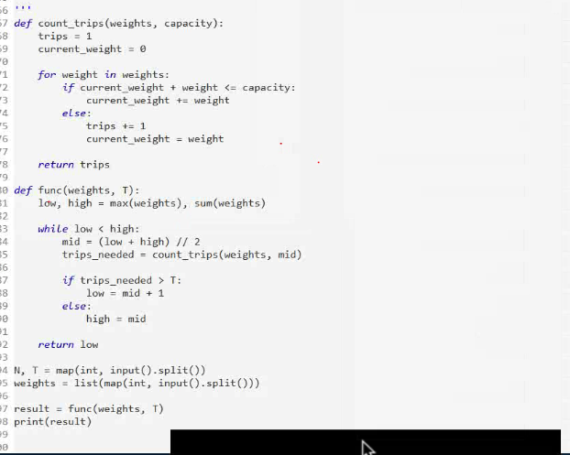

There are M students in a class, N students assigned with some tasks,

and the other M-N students have no tasks to do.

The task count of N students is given as an array, workload[], where N < M and

workload[i] is the number of tasks assigned to Student-I. and Also given

an integer P, the maximum number of distribution operations can be performed.

A distribution operation is defined as follows:

- Pick any student (Student_I), and distribute his/her workload with other

student (Student_J) who doesn't assigned any tasks yet in that class.

- e.g., if the student_I assigned 5 tasks, can be distributed as 1 task to

Student_I and 4 tasks to Student_J [ OR ] can be distributed as 2 tasks to

Student_I and 3 tasks to Student_J.

Your task is to help the students of the class, to minimize their workload,

by distributing their tasks with thier classmates, and

return the minimum possible workload after performing the operations.

NOTE: You can assume that the number of students required to

distibute the workload are sufficient.

Input Format:

-------------

Line-1: Two space separated integers, N and P

Line-2: N space separated integers, workload[].

Output Format:

--------------

Print an integer result.

Sample Input-1:

---------------

4 4

3 6 12 3

Sample Output-1:

----------------

3

Explanation:

------------

- Distribute the workload of 12 tasks like, One Student with 6 tasks

and Other Student with 6 tasks. Workload[]=[3,6,12,3] -> [3,6,6,6,3].

- Distribute the workload of 6 tasks like, One Student with 3 tasks

and Other Student with 6 tasks. Workload[]=[3,6,6,6,3] -> [3,3,3,6,6,3].

- Distribute the workload of 6 tasks like, One Student with 3 tasks

and Other Student with 6 tasks. Workload[]=[3,3,3,6,6,3] -> [3,3,3,3,3,6,3].

- Distribute the workload of 6 tasks like, One Student with 3 tasks

and Other Student with 6 tasks. Workload[]=[3,3,3,3,3,6,3] -> [3,3,3,3,3,3,3,3].

So, the minimized workload is 3 tasks.

Sample Input-2:

---------------

3 4

6 15 24

Sample Output-2:

----------------

8

Explanation:

------------

- Distribute the workload of 24 tasks like, One Student with 8 tasks

and Other Student with 16 tasks. Workload[]=[6,15,24] -> [6,15,8,16].

- Distribute the workload of 16 tasks like, One Student with 8 tasks

and Other Student with 8 tasks. Workload[]=[6,15,8,16] -> [6,15,8,8,8].

- Distribute the workload of 15 tasks like, One Student with 7 tasks

and Other Student with 7 tasks. Workload[]=[6,15,8,8,8] -> [6,7,8,8,8,8].

- Distribute the workload of 8 tasks like, One Student with 4 tasks

and Other Student with 4 tasks. Workload[]=[6,7,8,8,8,8] -> [6,7,4,4,8,8,8].

So, the minimized workload is 8 tasks.

